

W6 PRACTICE
FORMS & INPUTS

 What are the objectives for this session?
- Learn and use various HTML form input types
  - text, checkbox, radio, dropdown, text area, range, color, selector etc.

- Apply basic CSS styles to enhance the appearance of form inputs
  - borders, colors, padding, margins etc.

- Use: :focus :hover : checked :checked :indeterminate CSS pseudo-classes

 How to start?
✔ Download the start code from the LMS
✔ Open the folder in VS Code

 How to submit your work?
✔ Push your final code on your GitHub repository
✔ Then attach the GitHub path to the MS Team assignment and turn it in

 Are you lost?
You can read the following documentation to be ready for this practice:
- Guide - WC3 School
- The Form element
- HTML Forms



PART 1: LEARN – 45 MIN
- Read or watch resources on internet to learn about HTML Inputs: Guide - WC3 School
The Form element HTML Forms

- Complete the bellow table.

INPUT TYPE | USAGE | EXAMPLE
Text | defines a one-line input field for text input | <input type="text">
radio | Define a radio button | <input type="radio">
checkbox | Define a checkbox | <input type="checkbox">
range | defines a control for entering a number whose exact value is not important (like a slider control). | <input type="range" id="vol" name="vol" min="0" max="50">
Submit | defines a submit button which submits all form values to a form-handler | <input type="submit" value="request" />
textarea | defines a multi-line text input control | <textarea id="w3review" name="w3review" rows="4" cols="50">  At w3schools.com you will learn how to make a website. They offer free tutorials in all web development technologies.  </textarea>
select | used to create a drop-down list | <label for="cars">Choose a car:</label>  <select name="cars" id="cars">  <option value="volvo">Volvo</option>  <option value="saab">Saab</option>  <option value="opel">Opel</option>  <option value="audi">Audi</option>  </select>
color | Define a color picker | <input type="color" id="favcolor" name="favcolor" value="#ff0000">
file | defines a file-select field and a "Browse" button for file uploads | <input type="file" id="myfile" name="myfile">

- Read or watch resources on internet to learn about Inputs styling: https://www.w3schools.com/css/css_form.asp

- Complete those mini challenges by writing your code on bellow table:

MINI CHALLENGES | YOUR CODE (HTML + CSS)
Highlight the input field when it is focused | <input type=”text” name=”name”>  <style>  Input:focus {  Border:5px blue;  Outline:none;  Background-color:#f0f8ff;  }  </style>
Change the button background color on hover | <style>  Input:focus {  Border:5px blue;  Outline:none;  Background-color:#f0f8ff;  }  </style>  <button type=”submit”>Submit</button>
Create a search bar with rounded corners and a shadow effect | <!DOCTYPE html>  <html lang="en">  <head>  <meta charset="UTF-8">  <meta name="viewport" content="width=device-width, initial-scale=1.0">  <title>Rounded Search Bar with Shadow</title>  <style>  * {  margin: 0;  padding: 0;  box-sizing: border-box;  font-family: 'Segoe UI', system-ui, sans-serif;  }  body {  display: flex;  justify-content: center;  align-items: center;  min-height: 100vh;  background: #f5f7fa;  padding: 20px;  }  .search-container {  width: 100%;  max-width: 500px;  }  .search-bar {  width: 100%;  padding: 14px 20px;  font-size: 16px;  border: none;  border-radius: 30px;  background-color: white;  box-shadow: 0 4px 12px rgba(0, 0, 0, 0.1);  transition: all 0.3s ease;  outline: none;  }  .search-bar:focus {  box-shadow: 0 6px 16px rgba(0, 0, 0, 0.15);  }  .search-bar::placeholder {  color: #a0a0a0;  }  </style>  </head>  <body>  <div class="search-container">  <input type="text" class="search-bar" placeholder="Search...">  </div>  </body>  </html>
Display a different style when the checkbox is checked | }  .style5:checked + label::after {  content: '✓';  color: white;  position: absolute;  top: 50%;  left: 50%;  transform: translate(-50%, -50%);  font-weight: bold;  }  </style>  </head>  <body>  <div class="container">  <h3>Different Checked Styles</h3>  <div class="checkbox-item">  <input type="checkbox" class="style1" id="check1">  <label for="check1"></label>  <span>Simple color change</span>  </div>  <div class="checkbox-item">  <input type="checkbox" class="style2" id="check2">  <label for="check2"></label>  <span>Switch toggle</span>  </div>  <div class="checkbox-item">  <input type="checkbox" class="style3" id="check3">  <label for="check3"></label>  <span>Heart icon</span>  </div>  <div class="checkbox-item">  <input type="checkbox" class="style4" id="check4">  <label for="check4"></label>  <span>Circle with check</span>  </div>  <div class="checkbox-item">  <input type="checkbox" class="style5" id="check5">  <label for="check5"></label>  <span>Filled with shadow</span>  </div>  </div>  </body>  </html>
HARD!  Style a checkbox to have three states: unchecked, checked, and indeterminate.  TIP  Use CSS pseudo-classes (:checked and :indeterminate)  for styling. | <!DOCTYPE html>  <html lang="en">  <head>  <meta charset="UTF-8">  <meta name="viewport" content="width=device-width, initial-scale=1.0">  <title>Three-State Checkbox</title>  <style>  body {  font-family: Arial;  padding: 40px;  background: #f0f0f0;  }  .container {  max-width: 300px;  margin: 0 auto;  background: white;  padding: 20px;  border-radius: 5px;  }  .checkbox {  margin: 15px 0;  display: flex;  align-items: center;  }  input[type="checkbox"] {  display: none;  }  .check {  width: 20px;  height: 20px;  border: 2px solid #999;  margin-right: 10px;  cursor: pointer;  position: relative;  }  .checked .check {  background: #4CAF50;  border-color: #4CAF50;  }  .checked .check::after {  content: '✓';  color: white;  position: absolute;  top: 50%;  left: 50%;  transform: translate(-50%, -50%);  }  .indeterminate .check {  background: #FF9800;  border-color: #FF9800;  }  .indeterminate .check::after {  content: '-';  color: white;  position: absolute;  top: 50%;  left: 50%;  transform: translate(-50%, -50%);  font-weight: bold;  }  .state {  margin-left: 10px;  font-size: 14px;  color: #666;  }  </style>  </head>  <body>  <div class="container">  <h3>Three-State Checkbox</h3>  <div class="checkbox" id="checkbox1">  <div class="check"></div>  <span>Task status</span>  <span class="state">(Unchecked)</span>  </div>  <div class="checkbox" id="checkbox2">  <div class="check"></div>  <span>Project progress</span>  <span class="state">(Unchecked)</span>  </div>  </div>  <script>  document.querySelectorAll('.checkbox').forEach(box => {  let state = 0;  box.addEventListener('click', function() {  state = (state + 1) % 3;  this.className = 'checkbox';  const stateText = this.querySelector('.state');  if (state === 0) {  stateText.textContent = '(Unchecked)';  } else if (state === 1) {  this.classList.add('checked');  stateText.textContent = '(Checked)';  } else {  this.classList.add('indeterminate');  stateText.textContent = '(Indeterminate)';  }  });  });  </script>  </body>  </html>

- Some groups will be selected to present and explain their work to the whole class

PART 2: PRACTICE – 45 MIN
You need to reproduce – as close as possible - the bellow table. Before coding, identify the following point:
- Elements: What are the different inputs you will need?

- Layout: what kind of CSS layout do you need? Why?

- Input styling: What are the styles you need to apply on your inputs?
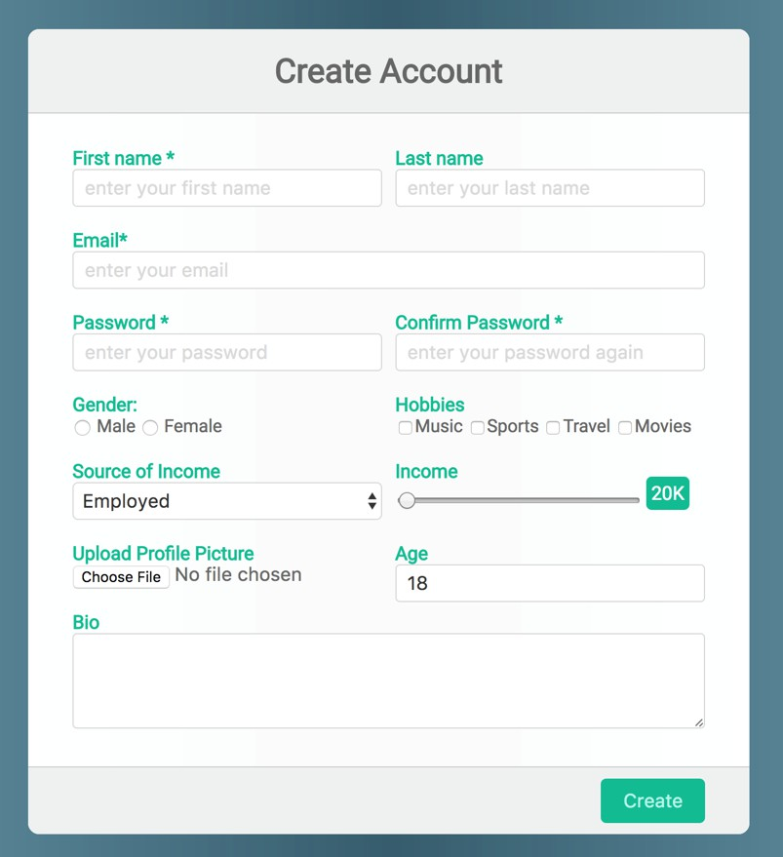
Be as close as possible from this mock up

